Q1: I want to ask a question about the idea of the RFM analysis. Many companies want to penetrate their customers to minimize risk, especially financial institutions. So, the Pareto principle does generally not fit their goals. How can RFM analysis helps these companies to segment their customers by penetrating?

Q2: In the material on the link (<http://www.dbmarketing.com/articles/Art123.htm>), standardization and normalization process were not applied on the dataset. When we work on RFM analysis, do we pass these processes? In the material, it is mentioned that FedEx was primarily interested in the monetary value rather than the recency of purchase. Therefore, can we say that the normalization process or coefficients of these three factors are based on the values of the given company?

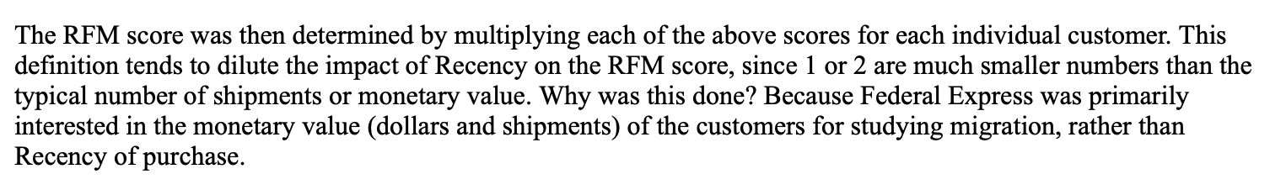

Q3: In the material on the link (<https://www.optimove.com/resources/learning-center/rfm-segmentation>), it is explained the steps of the RFM analysis. How should we define the metrics of the given period in recency and frequency? Should be they the same or different?

